Tior Gaming Case study

Tior Games predominant goal is excellent player experience. They needed their global users to have a consistent, fast, and always available high-quality player experience. The Covid-19 coronavirus outbreak has people spending more time at home than many of them are used to. Conveniently, a lot of them are turning to gaming to pass the time; putting pressure on game companies, including Tior in sometimes unexpected ways, including longer-than-usual queue times to get into League of Lovance games. League of Lovance is a free-to-play game that allows in game purchases, computer based MOBA.

The active servers Tior gaming has for their League of Lovance game are running at close to maximum capacity. Tior is working to increase server capacity by boosting the servers and in the meantime will whitelist all pro accounts and Tior Partners, enabling them to bypass queues and get straight into games. There is also an idea of creating a new server.

Four years ago Tior Gaming moved their entire data warehouse to Amazon AWS, Hive. You are given access by the company’s DBA to a small number of the company’s data marts, which are based on their data science stored data.

Your goal is to investigate what Tior gaming can do to improve player experience further during these difficult times. You have to propose a solution based on querying the data provided in the data marts and then create a visual business presentation for Tior’s Board.

Delay fact table components explanation:

* Latency (Ping): The amount of time, in milliseconds, it takes data packets to travel from your computer to Riot game servers and back.
* Packet-Loss: The number of data packets that don’t make it to their intended destination, whether that’s back to your computer or towards Tior game servers.
* Jitter: The change in latency between data packets. A jitter measurement is the p-p average over a 30 seconds duration.

You can calculate the connection score using:

CONNECTION QUALITY SCORE = 100 - (Average Latency * X + Average Jitter * Y + %Packet-Loss * Z) x, y, and z represent constants used to assign more weight to metrics that have a greater impact on the connection quality.

**To access the data mart:**

Connect to the university’s VPN.

Go to Azure data studio, connect with your login details as we did in the workshop and are detailed on Moodle.

Select the TiorGaming database. You are **NOT** allowed to use any other data warehouse.

You are provided with the following diagram.

Keep in mind that although it seems like one data warehouse these are fragments of 2 different data marts, provided to you for security reasons.One data mart includes the delay and players fact tables and the other has the games fact table.

(link: <https://lucid.app/invitations/accept/99289f67-3ec6-4e36-aca0-3e8d70b64d64>):

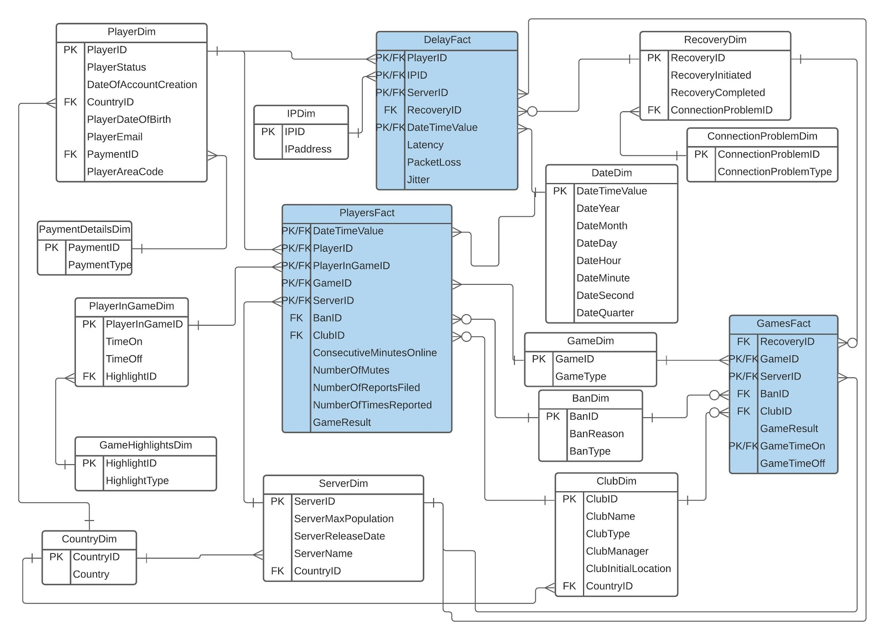

The data dictionary is also provided in a separate file link: <https://drive.google.com/file/d/10rriA_oxoLa5oKQR8zsmWswe6Vdja72q/view?usp=sharing>

Task 1: Individual - Data warehouse

Use the Tior Gaming data warehouse.

Submit a PDF file - report of up to 2000 words in total, answering ALL of the following questions:

You must include references to where is needed.

Question 1

Write and run **5 SQL queries**. You must submit a screenshot of the queries running and its results as well as the short description of the rationale in no more than 100 words per query.

*Notes:*

* Your queries must be meaningful and demonstrate the strength of DW in supporting decision makers.
* Your queries must use a broad range of fact tables and dimensions of the provided DW.
* You should provide a short description of each query, to explain the rationale for creating it.
* All 5 queries must be different from each other, using different fact tables and dimensions.
* All 5 queries should include at least one data warehouse concept. Queries such as select * from tablename and repetitive queries, will get marked as zero.

{Total marks: 20}

Question 2

Modify the given schema and suggest at least 2 more dimensions that would provide you with insights that you wish there were there. You must submit the 2 dimensions, the data dictionary for them and the rationale report.

*Notes*:

* Provide reasoning and rationale for your choice (also known as: why these dimensions and how can we use them?) in no more than 400 words.
* You need to submit these two dimensions, following the same naming convention that exists in the data warehouse.
* These two dimensions should seamlessly blend together with at least one fact table or dimension of the current data marts.
* You have to include a data dictionary following the same format of the given data dictionary.

{Total marks 16}

Question 3

You are given this query from one of your data junior analysts:

Select DATEDIFF(minute,  gamesfact.GameTimeOn,gamesfact.GameTimeOff)

as GameDuration

From PlayerInGameDim

inner join PlayersFact on PlayerInGameDim.PlayerInGameID = PlayersFact.PlayerInGameID inner join GameDim on PlayersFact.GameID = GameDim.GameID inner join GamesFact on TimeOn = GameTimeOn ;

He is interested in finding out why this is not working. Your task is:

* To describe what the correct version of the query does (no more than 100 words)
* To identify the problem (no more than 100 words)
* To solve this problem the best way possible - keep in mind that the rationale of the query must remain the same. Feel free to modify everything (data, dimensions, fact tables or query or an assortment of them) to achieve the same rationale and discuss it in not more than 400 words.

*Note*:

You must submit a screenshot of the final query running and its results (including error).

You are not allowed to alter the data, if you decide to make changes on the schema or the data, for this query’s rationale to work, you have to report them in writing.

{Total marks 6}

Question 4

A common way of introducing data warehousing is to refer to its fundamental characteristics. Describe three characteristics of data warehousing. Use no more than 250 words in total.

{Total marks 4}

Question 5

Sometimes a fact table references a dimension table multiple times as a foreign key. Provide two generic examples that justify the given statement.

For example, an employee and her manager are related to the same fact table in workforce-related analysis.

Use no more than 150 words in total.

{Total marks 4}